WEEK 4
23BCE1505
Arna Bhattacharya

Activity Diagram
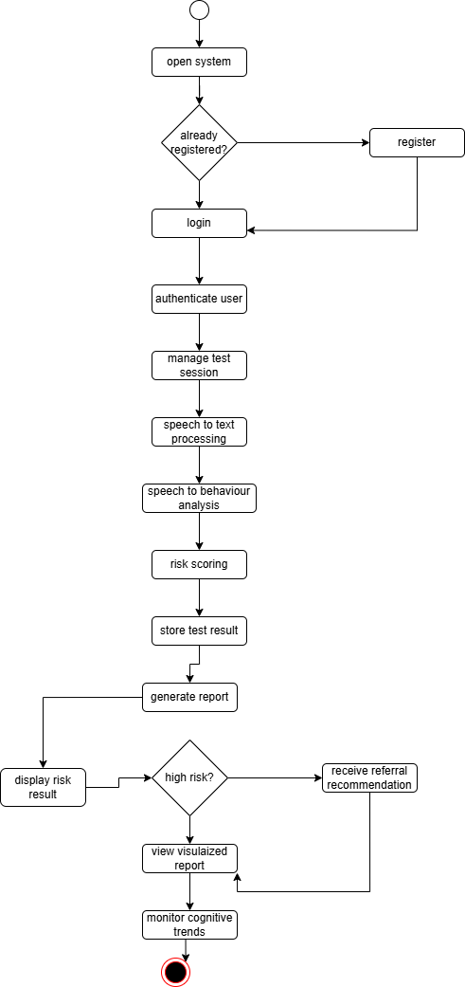

Sequence diagram

